**TEAM NAME:** SRM

**PROBLEM STATEMENT**: DEV_01

**TECH STACKS USED**: html, CSS+Bootstrap, vanilla Javascript

**VIDEO LINK**: <https://drive.google.com/file/d/1YrBRMeSnEDHQ9f-8MGNwW_BOm0quqiP_/view>

**PROJECT LINK:** <https://github.com/manavagr1108/TRINIT_SRM_DEV01>

**INTRODUCTION:**

Develop a solution through which a person can create a website just by dragging and dropping elements.

**PROPOSED METHOD:**

-build a basic website using our web app

-components include navbar, footer, cards, images and other basic html elements.

-**FUNCTIONALITY:**

* User can choose from a number of components which he can drag around the screen and place them according to their requirements.
* Single Click displays the CSS style of the chosen element.
* Double Clicking on an element removes it.
* Hovering on certain elements like buttons, cards will trigger hover and click animations.
* Blue highlight border displays the element that the cursor currently points to.

-**METHOD:**

* Generation of new elements is done by appending children in the **userbody** div.
* Dragging and dropping of elements is implemented using **dragElements** function, which basically gets the cursor position and as the mouse is dragged it reassigns the top and left attributes of the element.
* To generate advanced components like navbar, card, footer: we have used bootstrap classes and appended them in the same way as other basic HTML elements.

**WORK DONE:**

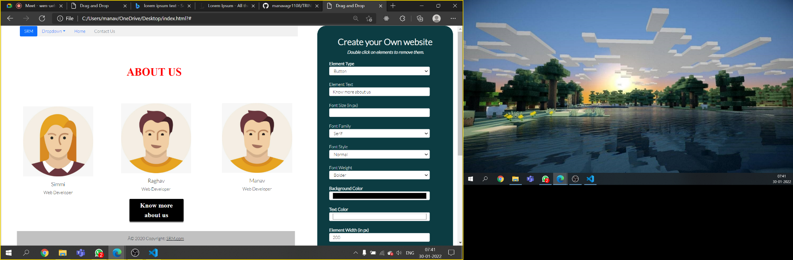

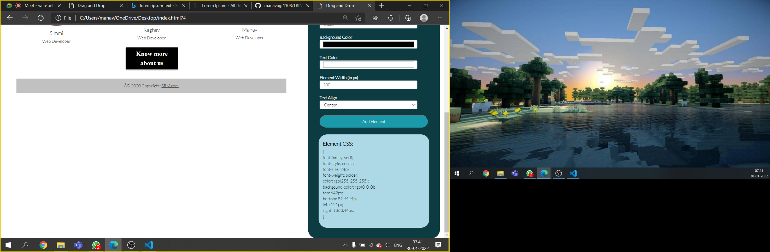

**CONCLUSION:**

Our site can be used by a novice web developer to build his own website by dragging and dropping elements to the main screen, styling them according to his requirements and also generating corresponding CSS.

**REFERENCES:**

<https://www.w3schools.com/js/default.asp>

<https://startbootstrap.com/themes>

<https://stackoverflow.com/questions/6860853/generate-random-string-for-div-id/6860962>